Lab 4 - 9: Synthesizing Wintergreen Utilizing PCR, Gene Cloning, and Bacterial Transformation
Dr. Kucknoor
BIOL 4404, Molecular Biology, Spring 2025
3/19/2024
Andrew Kalathra

Introduction:
In general, synthetic biology means “hijacking” biological processes and systems to produce what we want. In this experiment, we were challenged to utilize a BSMT1 enzyme template sequence to create methylsalicylate, which is most notable for its wintergreen scent. Major questions included such: How can we replicate DNA in vivo? How can we get DNA into bacteria and force them to express the sequence of interest? How can we ensure that only the bacteria that contained our sequence of interest were kept and all others eliminated? Finally, how do we force the expression of our gene sequence of interest?
This experiment was done over the course of five successive weeks, where each week focused on a major laboratory technique that has advanced the field. These included a focus on PCR, restriction enzymes, DNA cloning (recombinant DNA technology) through ligation, transformation, and finally, targeted activation of a gene sequence.
Methodology:
Starting with 5 μL of our DNA template in a 0.2 µL PCR tube, we added 25 µL of a primer mix and a PCR bead. The primer mix was composed of the dNTPs, and the bead was composed of Taq polymerase along with MgCl₂, a needed cofactor for Taq polymerase. When not in use, this solution was kept on ice until all the required elements were added. Following this, the solution was mixed well through a regurgitating pipetting technique (up and down). After finishing this step, the PCR tube was labelled and placed with other groups to follow a thermocycler program. This program consisted of putting the solution under 94 °C for 5 minutes and then doing a cycling method consisting of the following three steps: 94 °C for 30 seconds, followed by 56 °C for 30 seconds, followed by 72 °C for 75 seconds. This cycle was continued 30 times and was then followed by 1 cycle of 72 °C for 5 minutes and then left at a low temperature of 4 °C for a week. This step concluded the PCR portion.
The following week, 3 μL of this DNA insert was then transferred to another tube to analyze the results via electrophoresis. Alongside this, 3 μL of loading dye and 14 μL of water were added and gently mixed. The electrophoresis solution was then loaded on a gel and analyzed. With the rest of the DNA insert from the prior week, 25 μL was extracted and placed in a microcentrifuge tube. A quantity of 300 μL of purification buffer was then added to the microcentrifuge tube, which was then inverted gently 6 times. Obtaining a spin column and reservoir tube, the mix was then added to the spin column. This column was then centrifuged for 1 minute at 6000 rpm. The flow-through was then discarded in a specified waste beaker, and 700 μL of wash buffer was added again followed by another round of centrifugation for 1 minute at 6000 rpm. The flow-through was yet again discarded in a similar fashion, but the reservoir tube was then replaced. Following these two washes, 1.5 mL of PCR insert and 25 μL of ultrapure water were added to extract the DNA that was stuck to the filter at the bottom of the spin column. After leaving for a minute to absorb on the filter, the column was then centrifuged at 13,000 rpm. The spin column was then discarded, and the reservoir tube was kept as it contained our DNA. This concluded the DNA purification step.
The following weeks procedure used the products in an attempt to insert the sequence into a plasmid. To the reservoir tube, 5 μL of restriction enzyme buffer, 10 μL of enzyme mixture, and 10 μL of ultrapure water were added. The solution was mixed through the regurgitating pipetting technique and was given a “quick spin”, in that it was kept in the centrifuge and taken out after ~3 seconds. This homogenous mixture was then incubated in a water bath for 1 hour at 37 °C. Following this, the solution was then incubated for 20 minutes at 70 °C. This solution was then used for ligation, in which 10 μL of the solution (Digested PCR insert) alongside 5 μL of digested vector and 15 μL of ligation buffer – T4 DNA ligase mix was all added to an Eppendorf tube. This solution was then mixed gently and left at a cold 4 °C until the following week.
Picking up the following week, two Eppendorf tubes were obtained and used in a similar fashion, one as a control and the other for ligation. The tubes contained 1.5 mL of E. coli and were centrifuged for 2 minutes at 13,000 rpm. The supernatant was then discarded in a designated waste beaker, with special care taken so as to not disturb the pellet formed at the bottom. When not in use, these tubes were kept on ice. Alongside this, ice-cold CaCl₂ solution was used to resuspend the pellets along with the regurgitating pipette technique. The tubes were then kept on ice to incubate for 20 minutes. Following this allotted time, the tubes were centrifuged for 2 minutes at 13,000 rpm, resulting in a supernatant and pellet, of which the supernatant was discarded in the same waste beaker. Following this, 100 μL of ice-cold component cell solution was then added to each tube followed by the regurgitating pipette technique to resuspend the pellet. Yet again, CaCl₂ was added and mixed to each tube using the regurgitating pipette technique. Up till this portion, both tubes received the same treatment and chemicals, yet the purpose was distinct. At this point, the “Ligation” tube received 10 μL of the solution from the prior week, whereas the “Control” tube received 10 μL of control DNA. After using the regurgitating pipette technique, both tubes were then treated similarly to an ice bath incubation for 15 minutes. This was quickly followed by a 45 second water bath in 42 °C, which was then quickly followed by an ice bath incubation for 2 minutes. The tubes were then mixed with a gentle flick after the addition of 250 μL of Recovery broth. The tubes were then incubated in a 37 °C water bath for 30 minutes. During this time, three petri plates were obtained and labelled with their respective purpose, two for “Ligation” and one for “Control”. After the 30 minutes, the solutions were then plated, utilizing around 250 μL of the respective solution. The plates were then incubated for a week. Prior to utilizing the plates, they were analyzed two days into incubation to ensure that growth had taken place.
The following week, a colony on one of the ligated plates was isolated and grown in a tube containing LB + kanamycin broth. Additionally, a colony from the control plate was also isolated and kept in another tube with the broth. The tubes were left for three hours, after which IPTG and salicylic acid were added and allowed to incubate for 15 hours. The next day, the tubes were analyzed via a smell assay, utilizing both a negative control of E. coli broth and a positive control of wintergreen oil extract.

Results:
The week following the initial PCR, the resulting solution was analyzed via electrophoresis. Doing this experiment in company with peers, each lane on the electrophoresis gel was appropriated, ours being lane 6. Utilizing the ladder, the solution contained a DNA sequence close to 1568 base pairs (bp). Comparing this to other groups as well as the expected results, this most likely was a successful PCR, though the actual length of the original DNA template is unknown.

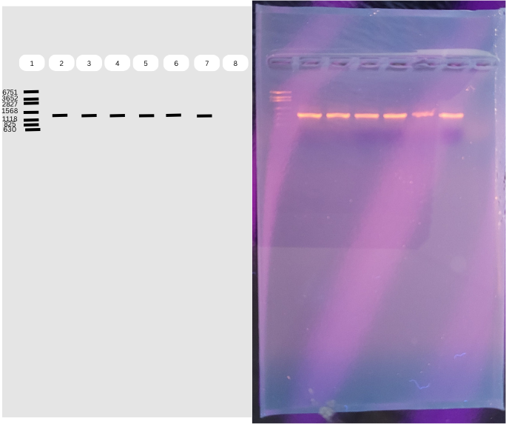
Figures 1 Labelled Electrophoresis Gel. Lane 6 of importance. Ladder in base pairs (bp) is given on Lane 1, denoted as “1”. [4]
The following 3 weeks contained no relevant statistical or graphical results. When cloning the DNA, the “Ligation” and “Control” batches were plated. As expected, the control contained colonies, indicating that the technique used did not harm the bacteria. Both ligation plates contained a few colonies, with more presenting on the second of the ligation plates.
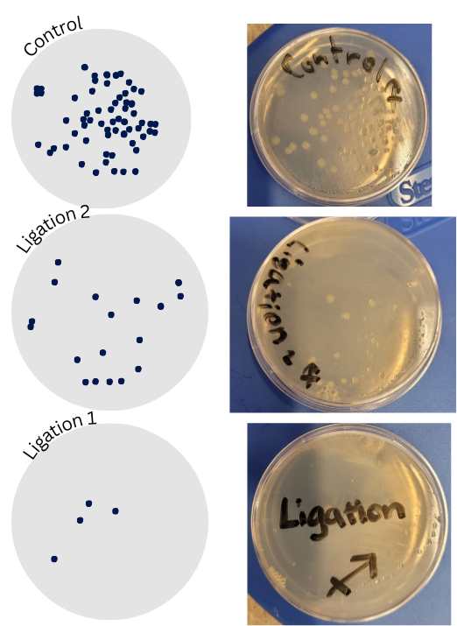
Figures 2 Labelled Petri Plates for Ligation and Control
A ligated colony that was isolated and extracted was grown in LB + kanamycin broth. After optimum growth conditions and with the addition of the necessary substrates, a smell assay was performed. Utilizing multiple colleagues over the course of 5 minutes, the tube presented with a reasonable wintergreen smell. This tube was compared against an E. coli tube as a negative control and against pure wintergreen extract as a positive control.
Discussion:
The overall experiment was a success, utilizing the BSMT1 enzyme DNA template to then produce the wintergreen scent. The process took place over the span of five weeks and utilized a variety of techniques and methods.
The experiment began by utilizing the simple but revolutionary process of PCR. Polymerase Chain Reaction utilizes the prokaryotic cellular enzyme DNA polymerase. Polymerase is found in all cells for replication, so utilizing it to replicate a gene of interest would seem simple, but the complications include the necessary environment and procedural steps needed to be done to continue duplicating the gene of interest. Under these conditions, it is most optimal that three main phases take place. The first phase is to denature the double stranded DNA to create single stranded DNA, similar to how helicase would open the strand to allow DNA polymerase to function in situ. In vivo, heat can be utilized to perform a similar function, so the denaturing conditions are to heat the solution to ~95 °C. The next step is to provide the right conditions for DNA polymerase to join. Heating the solution up, however, will most likely kill normal DNA polymerase, and reintroduction of DNA polymerase at this step every cycle would be both costly and time consuming. The solution to this problem was utilizing the DNA polymerase extracted from Thermus aquaticus, a thermophilic bacterium. As it naturally is resistant to heat, the polymerase inside, labelled as Taq polymerase, should be able to survive at the necessary temperatures for PCR to operate. This, however, is not the optimal conditions for functioning, which require a temperature of ~55 °C to attach to the DNA, and ~72 °C to replicate. The specific timings for each phase are around 30 seconds for the first two phases and 75 seconds for the last phase. As a well-known and very useful technique, PCR machines are commonly utilized to automate these steps. This experiment ran 30 cycles using a PCR machine. All the components needed for this first step of the experiment were the primer mix, the DNA template, and a PCR bead. The primer mix was a mix of RNA primers that allow the DNA polymerase to start replication in the same reasoning why RNA is needed to be placed before the DNA polymerase can begin replication. The primers used were customized to this sequence, but most likely contained a large amount of G-C base pairs as it has been shown to produce better results. The DNA template was for the BSMT1 enzyme gene, which was the purpose of the experiment. The PCR bead contained a few necessary components. Firstly, it contained the Taq polymerase as previously discussed. Secondly, it contained MgCl₂, a needed cofactor for DNA polymerase. Lastly, the bead contained dNTPs, or deoxynucleotides, which are the needed bases to be put down in the right sequence, similar to how roadbuilders need cement to do their job.
As shown in Figure 1, a portion of the resulting DNA from PCR was analyzed via electrophoresis. While inserting the DNA into the gel, a small portion of pipette entered the bottom of the gel, leading to the slight haze shown in the figure, though the band is clearly visible. The rest of the purification procedure went smoothly, centrifuging the DNA insert utilizing a spin column, a reservoir tube, purification buffer and wash buffer to get the extra contents away from the DNA. The first two centrifuge steps collected the flowthrough in the reservoir tube while the product of interest remained on the spin column. To then extract the DNA from the mesh on the spin column, a new reservoir tube was obtained, ultrapure water was added, and centrifugation commenced, resulting in purified PCR DNA, labelled PCR insert, at the bottom of the reservoir tube.
Having the DNA did not mean that it could simply be put into a cell and that the enzyme would start being made. In normal E. coli, exogenous genetic material is usually cut upon entering the cell, which is advantageous as not to allow pathogenic genetic material to freely float and perhaps even harm the cell [8]. In this lab, this issue was circumvented through the use of modified E. coli.
Even so, the transcription of the inserted genes is never guaranteed, and not even controlled. Utilizing plasmids, however, offers a solution to both of these issues. Plasmids can be thought of as powerups gained through a variety of methods, the most common being introduction by loosening the cell membrane and cell wall, also known as transformation. We can utilize this as many bacteria utilize plasmids to help them survive or even transfer genetic material (F plasmid for pilus). Introducing the DNA of interest into a plasmid would be ideal, as this can then be put into the E. coli. To insert the DNA into the plasmid, we first had to cut the DNA at two specific sites, which was possible since we were able to utilize two endonucleases. These endonucleases, EcoRI and Hind3, were extracted from bacteria (E. coli and Haemophilus influenzae respectively) with a main function of cutting foreign material, acting as the driving force in the discussion on introducing raw genetic material to E. coli. These two endonucleases recognize specific palindromic sequences where the splicing takes place, as shown by Figure 3.
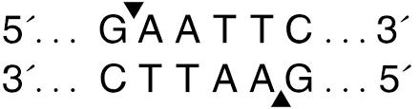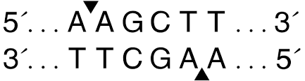
a b
Figure 3. a) EcoRI restriction site; b) HindIII restriction site [3][6]
These restriction endonucleases, also known as restriction enzymes, were combined with the PCR product to expose important ends of our DNA, all within the proper environment for the enzymes to act, which included the right buffer of restriction enzyme buffer, the right temperature of 37 °C, and a sufficient amount of time being an hour. These restriction enzymes were key to us as they were also used to slice the plasmid at the same sequences. As shown in Figure 3, both restriction enzymes cut at different spots, in that the location is not at the exact same location spatially on both strands. As such, this leaves an overhang, also known as a sticky end, which allows the DNA we cut and the plasmid that is similarly cut to join at their respective ends. It is important to note that two separate restriction enzymes were used to get the orientation right. This process of adding the DNA of interest into the plasmid is called ligation. The major components used included the digested PCR insert, the digested vector (plasmid), the ligation buffer, and the DNA ligase to create the right environment for double strand joining. After a mix, this solution was left to react over the course of the following week.
By this time, the plasmids were reassembled and were ready to be transformed. Two E. coli starter cultures were obtained, one for the ligation portion, and the other for the control. The viable E. coli were separated by centrifugation and isolated by pouring out the supernatant. Ice cold CaCl₂ was then added to both tubes. CaCl₂ is a common ingredient used to make competent cells, or cells that can take in exogenous DNA [2][1]. Utilizing a divalent cation, such as Ca²⁺ allows the cell surface to be neutralized by the creation of coordination complexes while also allowing the negatively charged DNA to become more neutral and hold closely to the cell membrane, though this is more of a theory than a fact [1]. Keeping the bacteria cold also causes them to “contract” in theory, which is a good setup for the rapid expansion that would happen later due to the heat, also known as the heat shock step. In this current step, the regurgitating pipette method was used to resuspend the cells. While doing this method, as the cells are cold and fragile, it is important to take this step with caution, which I did not. The tube I did this for was then labelled the control in hopes that if this was a cause of an error, it would not affect our major results. Great care was taken after this step so as to not harm the cells through any further stress. After resuspending the cells and incubating them on ice for 20 minutes, the tubes were centrifuged at full speed to once again pull everything away from the cell. The result of this step was a cell pellet as the supernatant was discarded. Following this, ice cold component cell solution was added to keep the cells cold. This solution was then resuspended utilizing the regurgitating pipette technique. Ice cold CaCl₂ was added and gently mixed. The distinction between the two tubes was finally of importance at this stage as 10 μL of the ligation DNA and the control DNA were added to their respective tubes and were gently mixed via regurgitating pipette. This solution was then incubated on ice for 15 minutes to prepare the solution for the heat shock, which came right after. This step included putting the tube in a pre-heated water bath that hovered around 42 °C followed by quickly withdrawing it after 45 seconds to allow it to incubate back on ice for at least 2 minutes. This step is vital as it allows the DNA that is closely linked to the cell membrane to quickly get inside the cell as the cell membrane expands rapidly while creating pores. These pores are then closed as the cell returns to the cold environment and the cell “contracts”. Recovery broth was then added and mixed via flicking, and then both tubes were incubated for 30 minutes at room temperature. In the waiting period, 3 antibiotic petri plates were obtained and labelled, one for the control and two for the ligation tube. The plasmid contained antibiotic resistance genes so that any colonies that were successfully transformed would be the only colonies left on the plate. After the waiting period, the cells were plated and left at 37 °C (optimum growth temperature for E. coli).
Two days later after the start of the incubation, the plates were observed, yielding the results provided in Figure 2. The growth on the control and ligated plates showed that damage was not extensive enough to harm all the batch. Four days later, a colony from one of our ligation plates and a colony from the control plate were extracted and placed (separately) in a LB + Kanamycin broth tube. This allowed the transformed E. coli to grow for 3 hours. Following this time, IPTG was added to the culture alongside salicylic acid, followed by another 15 hours of incubation. LB, or lysogeny broth (or Luria Bertani broth), is a normal growth media for bacteria, and kanamycin is the antibiotic that the plasmid helps to resist. By placing the cell in this environment, this both provides the right nutrients and space for growth while also restricting the growth to only that of cells containing the plasmid, also forcing the plasmid to be replicated for bacterial survival (the same process happening on the plate). IPTG, or isopropyl β-D-1-thiogalactopyranoside, is a reagent that acts similarly to allolactose in that it takes off a repressor for the lac operon [7]. Though the actual components of the vector were undisclosed, we can assume that by the addition of IPTG, which is commonly used for vector expression, that the vector contained a lac operon which now included our gene of interest. In a proposed architecture shown in Figure 4, the IPTG would most likely bind to the repressor found on the T7 promoter, allowing for the transcription of the gene of interest that was most likely introduced in the ORF region [7].
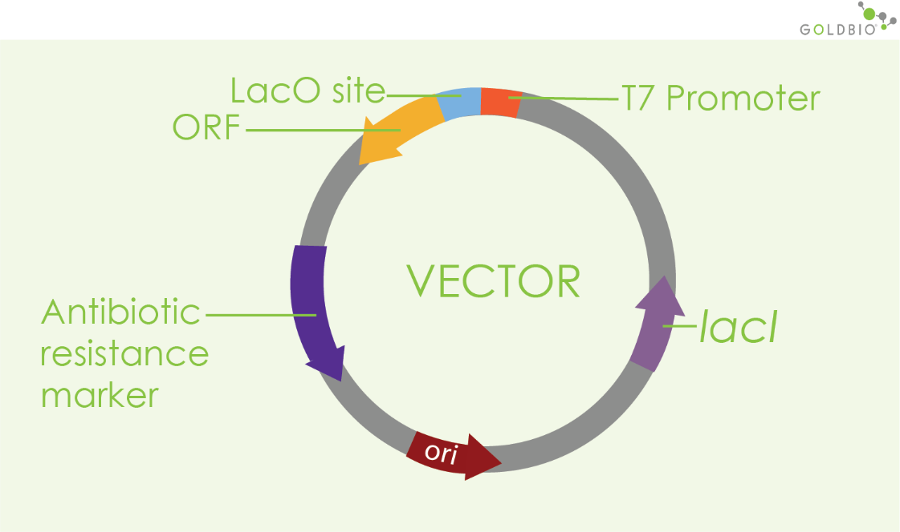
Figure 4. Basic Vector Architecture. ORF site as the proposed site of gene of interest. [7]
As the gene of interest is expressed, the product of BSMT1 is a carboxyl methyltransferase. As the name implies, this is an enzyme used for transferring a methyl group to the hydroxyl oxygen found on carboxylic acids, as shown in Figure 5. This process requires salicylic acid, which was introduced alongside IPTG, to make the wintergreen smell given by methylsalicylate.
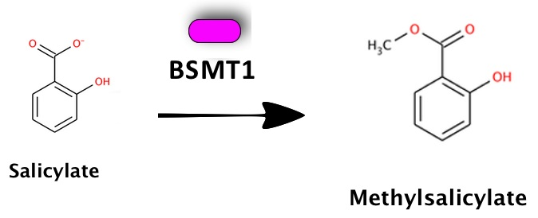
Figure 5. Reaction mechanism of Salicylic acid and BSMT1 [9]
The day after these substrates were added, a smell assay was performed. The tubes were shaken prior to smelling, and a positive control of pure wintergreen extract and a negative control of a normal E. coli culture were used. Though my olfactory sense is not ideal, cross checking between peers and the instructor proved the experiment was a success through the creation of a wintergreen scent. This experiment shows the basics of the powerful use of synthetic biology. Through the utilization of a variety of techniques, we can “hijack” naturally occurring processes to create what we want, of which in this case was a wintergreen smell. This process is widely used in parts in many laboratories. In the future, we could expect to see even more modifications to these steps as more efficient and cost-effective methods are developed.

References:
[1] CACL2 Transformation Technique - MyBioSource Learning Center. (2023, March 2). MyBioSource Learning Center. https://www.mybiosource.com/learn/testing-procedures/cacl2-transformation-technique
[2] Chen, A. (2023, October 31). DIY Chemically Competent Cells: Easy 10-Step Protocol. Bitesize Bio. https://bitesizebio.com/30145/chemically-competent-cells/
[3] EcoRI. (n.d.). New England Biolabs. Retrieved April 18, 2025, from https://www.neb.com/en-us/products/r0101-ecori
[4] EdvoTek. (n.d.). DNA Standard Marker. https://www.edvotek.com/site/pdf/NewStandardMarkers.pdf
[5] EDVOTEK, Inc. (2024). Synthetic Biology. In EDVO-Kit #331. https://www.edvotek.com/site/pdf/331.pdf
[6] HindIII. (n.d.). New England Biolabs. Retrieved April 18, 2025, from https://www.neb.com/en-us/products/r0104-hindiii
[7] Kroemer, T. (n.d.). How Does IPTG Induction Work? GoldBio Gold Biotechnology. Retrieved April 18, 2025, from https://goldbio.com/articles/article/how-does-iptg-induction-work
[8] Ng, D. (2024, July 24). A brief history of CRISPR-CAS9 Genome-Editing Tools. Bitesize Bio. https://bitesizebio.com/47927/history-crispr/
[9] Part:BBA K1065101 - parts.igem.org. (n.d.). https://parts.igem.org/Part:BBa_K1065101

